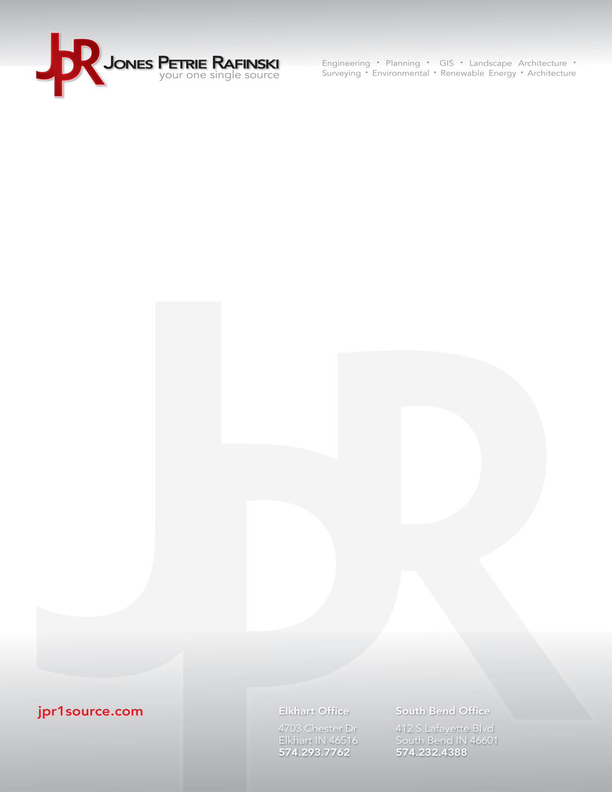

June 5, 2017

Amy Schweitzer, AICP

City of Auburn, Department of Building, Planning, & Development

210 S. Cedar St., 2nd Floor

Auburn, IN 46706

Attention: Ms. Amy Schweitzer

Re: **City of auburn Comments For the auburn 6th & Main streetscape plans**

Dear Ms. Schweitzer

Thank you for sending the plan review comments.

Please find the following responses to your comments:

**Electric/AES Department – Rob Higgins**

1. Approved.

**Fire Department – Mike VanZile**

1. Maintain a minimum of 20’ street width (accessibility for ladder truck set up).

* *We confirmed that both 6th and Main Street are at least 20’ in width, as noted on sheets C201-C203.*

**Engineering Department**

1. G100: Finish utilities contact information.

* *We have provided contact information for all utilities listed on G100.*

1. C202: Show 21.0’ and 26.0’ dimensions for back of curbs at intersection.

* *21.0’ and 26.0’ dimensions for back of curbs at the intersection have been added to C202.*

1. C202: can you show exact X & Y coordinates at center of 6th and Main.

* *Exact X & Y coordinates have been added at the center of the intersection of 6th and Main Streets on C202.*

1. All sheets: Remove all “E” Snow Route signs and detail

* *The “E” Snow Route signs have been removed from all sheets.*

1. C301 thru C303: Show all stationing on Line “S” and Line “M” and a station equation at 6th & Main intersection of “S” and “M”.

* *All stationing on Lines “S” and “M” are now shown on C301 thru C303. A station equation is now shown at the intersection of Lines “S” and “M”.*

1. C402: STR #17 show 12” pipe 5’ to east with pipe plug on plan and profile views.

* *At STR #17, a 12” pipe extending eastward with pipe plug is now shown on both the plan and profile views of C402.*

1. SD101: Standard curb detail: Location of sawed joint? And show (2) #4 rebar (continuous).

* *The location of the sawed joint has been updated to be accurate and (2) #4 rebar (continuous) are now shown in the standard curb detail on SD101.*

1. SD101: Detail #2: The (3” #53 compacted aggregate) needs to be crushed limestone, same as the 7” depth of #2’s.

* *The note has been revised on Detail #2 on SD101 to state that the 3” #53 compacted aggregate is to be crushed limestone (like the 7” depth of #2’s).*

1. Project Manual: cover page says Decatur. Update table of contents to match the PM pages. I’m still reviewing the PM.

* *The project manual cover now says Auburn. The table of contents has been updated to match the pages of the project manual.*

1. C301 thru C303: Need site benchmark, use 1988 Datum not 1927 Datum.

* *Site benchmarks (using the 1988 Datum) have been added on a new sheet within the plan set (C101 – Horizontal/Vertical Control Plan).*

**Water Department – Randy Harvey**

1. Should probably note somewhere that when water main valve and service valve boxes, and meter pit castings, are found to need raised or lowered to match grade, contact the Auburn Water Department.

* *A note has been added to the Demolition and Grading Plans stating that the contractor shall contact the Auburn Water Department if water main valve and service valve boxes or meter pit castings are found to need raised or lowered to match proposed grade.*

**Street Department – Bill Brandon**

1. Presently, there is one handicap parking space on Sixth Street (just outside Jeremiah’s). The plans do not have a handicap parking space. We believe there should be one.

* *We have updated the plans to include an ADA parking space along with the required van accessible loading space on the passenger side and required ADA ramp to the sidewalk. The total parking count was reduced by one space to achieve the ADA parking space.*

1. There are two existing Loading Dock signs. In looking at ways to reduce signage, Bill wondered if these two signs could be removed.

* *We will plan to remove these.*

1. Per the Mayor’s comments, the six “Snow Route” signs can probably be removed.

* *We will plan to remove these.*

1. There is a HOSPITAL directional sign mid-way on the 100 block of N Main Street. Bill believes this sign probably needs to stay, despite the fact it is not critical.

* *We will keep this sign.*

1. There is a brown/purple Historic District sign at the corner of Sixth and Jackson. Would this sign still be necessary?

* *This sign is most likely not a requirement, however the downtown will still be an historic district. We will plan to keep it at this point.*